Secure Weather API with Two-Factor Authentication
Documentation
Alexander Wilhelm

Description of this weather app
This project provides the ability to check the weather in Kosice. Users can retrieve real-time weather information, including: temperature, humidity, wind speed.
To enhance security the application includes: Token-based user authentication for controlled access
Two-Factor Authentication (2FA) to strengthen login security
A logging system that records failed login attempts

Technologies Used in the Project
Django
Django REST Framework
Token Authentication
Two-Factor Authentication (2FA)
Weather API
Logging Module (Python)

How to Check the Weather?
To check the weather, follow these steps
First, you need to create an account by sending a POST request to the registration endpoint:
Endpoint: http://127.0.0.1:8000/register/
Request body:
{
"username": "testuser",
"password": "testpass123"
}
Login to Receive the API Token:
After registration, you need to log in to receive your API token. Send a POST request to the login endpoint:
Endpoint: http://127.0.0.1:8000/login/
Request body:
{
"username": "testuser",
"password": "testpass123"
}
Set Authorization in Postman:
Once you have the API token, you need to add it to Postman in order to authenticate your requests.
Open Postman and go to the Authorization tab.
In the Type dropdown, select Bearer Token.
In the Token field, paste the API token you received like this: 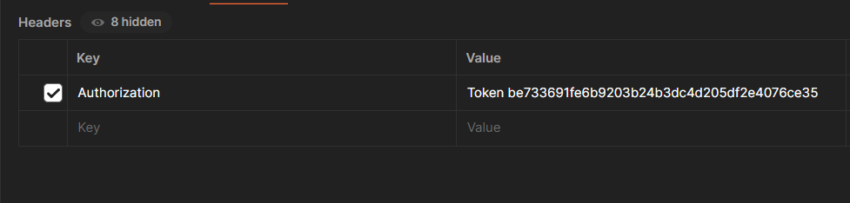

Access the Weather Data:
Now that you have set the token in Postman, you can access the weather data. Send a GET request to the weather endpoint with your API token in the authorization header:
Endpoint: http://127.0.0.1:8000/weather/?city=Kosice
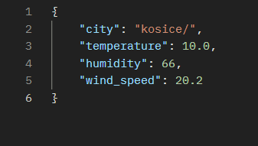

Token-Based Authentication for API Security
The API uses token-based authentication for security. When a user registers or logs in, they receive a token. This token must be included in the request headers for protected endpoints.
During registration (/register/), a token is created and returned:

@api_view(['POST'])
@permission_classes([AllowAny])
def register_user(request):
user = User.objects.create_user(username=username, password=password)
token, created = Token.objects.get_or_create(user=user)
return Response({'token': token.key})

During login (/login/), a token is generated if credentials are valid:

@api_view(['POST'])
@permission_classes([AllowAny])
def login_user(request):
user = authenticate(username=username, password=password)
if user is None: return Response({"error": "Invalid credentials"})
token, created = Token.objects.get_or_create(user=user)
return Response({'token': token.key})

For protected routes like /weather/, the user must provide a valid token in the headers:
@api_view(['GET'])
@permission_classes([IsAuthenticated])
def weather_view(request):
city = request.GET.get('city', 'Kosice')
response = requests.get(f"API_URL&key={API_KEY}&q={city}")
return JsonResponse(response.json())

Restricting Access to Endpoints with Token-Based Authentication
To restrict access to certain endpoints, token-based authentication is used. The @permission_classes([IsAuthenticated]) decorator ensures that only authenticated users can access specific views.
For example, the weather_view endpoint is protected and can only be accessed by users who are logged in and provide a valid token. Here's how it looks in the code:

@api_view(['GET'])
@permission_classes([IsAuthenticated])
def weather_view(request):
city = request.GET.get('city', 'Kosice')
url = f"https://api.weatherapi.com/v1/current.json?key={API_KEY}&q={city}"
response = requests.get(url)

if response.status_code == 200:
data = response.json()
return JsonResponse({
"city": city,
"temperature": data['current']['temp_c'],
"humidity": data['current']['humidity'],
"wind_speed": data['current']['wind_kph']
})
else:
return JsonResponse({"error": "Unable to fetch weather data"}, status=response.status_code)

In this example, users must be authenticated to access the weather_view endpoint. If the user is not authenticated, they will receive a 403 Forbidden response.

Logging Failed Login Attempts
The log_failed_attempt function is used to record failed login attempts to a JSON file for tracking purposes. It stores important details like the timestamp of the attempt, the username, the IP address from where the request originated, and the reason for the failure (e.g., invalid username or password). This helps in auditing and monitoring potential security issues or brute-force attempts.
The initialize_failed_logins_file function ensures that the log file exists and is properly initialized before any failed login attempts are logged. If the file doesn't exist or is empty, it creates a new JSON file to store the data.
Here’s the code:

FAILED_LOGINS_FILE = "failed_logins.json"
def initialize_failed_logins_file(file_path=FAILED_LOGINS_FILE):
if not os.path.exists(file_path) or os.path.getsize(file_path) == 0:
with open(file_path, "w") as file:
json.dump([], file)
initialize_failed_logins_file()
def log_failed_attempt(username, ip_address, reason):
failed_attempt = {
"timestamp": datetime.now().strftime("%Y-%m-%d %H:%M:%S"),
"username": username,
"ip": ip_address,
"reason": reason
}
with open(FAILED_LOGINS_FILE, "r") as file:
failed_logins = json.load(file)
failed_logins.append(failed_attempt)
with open(FAILED_LOGINS_FILE, "w") as file:
json.dump(failed_logins, file, indent=4)

